TITLE: COVID-19 VACCINE ANALYSIS

**Step-1: Problem Definition**

* The objective of this project is to conduct a comprehensive analysis of Covid-19 vaccine data, with a primary focus on vaccine efficacy, distribution, and adverse effects.
* The ultimate goal is to provide valuable insights that can aid policymakers and health organizations in optimizing vaccine deployment strategies.
* This multifaceted project encompasses data collection, data preprocessing, exploratory data analysis (EDA), statistical analysis, visualization, and the formulation of actionable recommendations.

**Step 2: Data Collection**

* We will gather Covid-19 vaccine data from reliable sources, including health organizations (e.g., WHO, CDC), government databases, and peer-reviewed research publications.
* The dataset located at (https://www.kaggle.com/datasets/gpreda/covid-worldvaccination-progress) will serve as a primary source.
* Data is collected daily from Our World in Data GitHub repository for covid-19, merged and uploaded. Country level vaccination data is gathered and assembled in one single file.
* Then, this data file is merged with locations data file to include vaccination sources information. A second file, with manufacturers information, is included.

#import all relevant libraries  
  
import pandas as pd  
import numpy as np  
import matplotlib.pyplot as plt  
import seaborn as sns  
  
from sklearn.metrics import accuracy_score, precision_score, recall_score, f1_score, confusion_matrix, classification_report

#loading the dataset  
data=pd.read_csv("C:\\Users\\velpr\\Desktop\\nm\\country_vaccinations.csv")

data.head()

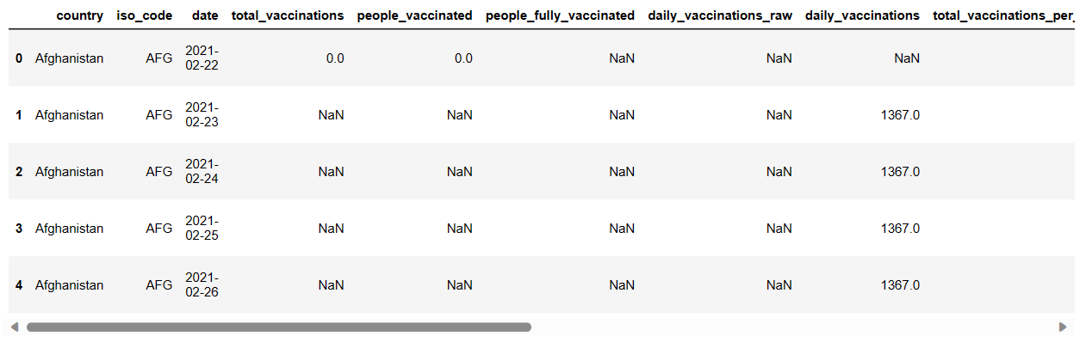

data.info()

<class 'pandas.core.frame.DataFrame'>  
RangeIndex: 86512 entries, 0 to 86511  
Data columns (total 15 columns):  
 # Column Non-Null Count Dtype   
--- ------ -------------- -----   
 0 country 86512 non-null object   
 1 iso_code 86512 non-null object   
 2 date 86512 non-null object   
 3 total_vaccinations 43607 non-null float64  
 4 people_vaccinated 41294 non-null float64  
 5 people_fully_vaccinated 38802 non-null float64  
 6 daily_vaccinations_raw 35362 non-null float64  
 7 daily_vaccinations 86213 non-null float64  
 8 total_vaccinations_per_hundred 43607 non-null float64  
 9 people_vaccinated_per_hundred 41294 non-null float64  
 10 people_fully_vaccinated_per_hundred 38802 non-null float64  
 11 daily_vaccinations_per_million 86213 non-null float64  
 12 vaccines 86512 non-null object   
 13 source_name 86512 non-null object   
 14 source_website 86512 non-null object   
dtypes: float64(9), object(6)  
memory usage: 9.9+ MB

data.describe()

total_vaccinations people_vaccinated people_fully_vaccinated \  
count 4.360700e+04 4.129400e+04 3.880200e+04   
mean 4.592964e+07 1.770508e+07 1.413830e+07   
std 2.246004e+08 7.078731e+07 5.713920e+07   
min 0.000000e+00 0.000000e+00 1.000000e+00   
25% 5.264100e+05 3.494642e+05 2.439622e+05   
50% 3.590096e+06 2.187310e+06 1.722140e+06   
75% 1.701230e+07 9.152520e+06 7.559870e+06   
max 3.263129e+09 1.275541e+09 1.240777e+09   
  
 daily_vaccinations_raw daily_vaccinations \  
count 3.536200e+04 8.621300e+04   
mean 2.705996e+05 1.313055e+05   
std 1.212427e+06 7.682388e+05   
min 0.000000e+00 0.000000e+00   
25% 4.668000e+03 9.000000e+02   
50% 2.530900e+04 7.343000e+03   
75% 1.234925e+05 4.409800e+04   
max 2.474100e+07 2.242429e+07   
  
 total_vaccinations_per_hundred people_vaccinated_per_hundred \  
count 43607.000000 41294.000000   
mean 80.188543 40.927317   
std 67.913577 29.290759   
min 0.000000 0.000000   
25% 16.050000 11.370000   
50% 67.520000 41.435000   
75% 132.735000 67.910000   
max 345.370000 124.760000   
  
 people_fully_vaccinated_per_hundred daily_vaccinations_per_million   
count 38802.000000 86213.000000   
mean 35.523243 3257.049157   
std 28.376252 3934.312440   
min 0.000000 0.000000   
25% 7.020000 636.000000   
50% 31.750000 2050.000000   
75% 62.080000 4682.000000   
max 122.370000 117497.000000

**Step 3: Data Preprocessing**

* Cleaning and preprocessing the data are essential steps in preparing it for analysis.
* This involves addressing issues such as duplicate records, inconsistent formatting, handling missing values, and converting categorical features into numerical representations.

data.dtypes

country object  
iso_code object  
date object  
total_vaccinations float64  
people_vaccinated float64  
people_fully_vaccinated float64  
daily_vaccinations_raw float64  
daily_vaccinations float64  
total_vaccinations_per_hundred float64  
people_vaccinated_per_hundred float64  
people_fully_vaccinated_per_hundred float64  
daily_vaccinations_per_million float64  
vaccines object  
source_name object  
source_website object  
dtype: object

data.isnull().sum()

country 0  
iso_code 0  
date 0  
total_vaccinations 0  
people_vaccinated 0  
people_fully_vaccinated 0  
daily_vaccinations_raw 0  
daily_vaccinations 0  
total_vaccinations_per_hundred 0  
people_vaccinated_per_hundred 0  
people_fully_vaccinated_per_hundred 0  
daily_vaccinations_per_million 0  
vaccines 0  
dtype: int64

**Step 4: Data Exploration**

* Perform exploratory data analysis (EDA) to understand the data's distribution, correlations, and trends.
* In this phase, we will dive into the dataset to gain a deeper understanding of its characteristics. EDA will involve generating statistical summaries, visualizing data distributions, and identifying trends and outliers.
* Key areas of exploration include vaccine distribution across regions, vaccination rates over time, and potential anomalies.
* Visualize the data to gain insights into vaccine distribution and adverse effects

#data cleaning data transformation data reduction  
#drop irrelevant variables  
data=data.drop(['source_name','source_website'],axis=1)  
#identifying and treating missing values  
data.isnull().sum()  
data=data.fillna(0)

data.head()

country iso_code date total_vaccinations people_vaccinated \  
0 Afghanistan AFG 2021-02-22 0.0 0.0   
1 Afghanistan AFG 2021-02-23 0.0 0.0   
2 Afghanistan AFG 2021-02-24 0.0 0.0   
3 Afghanistan AFG 2021-02-25 0.0 0.0   
4 Afghanistan AFG 2021-02-26 0.0 0.0   
  
 people_fully_vaccinated daily_vaccinations_raw daily_vaccinations \  
0 0.0 0.0 0.0   
1 0.0 0.0 1367.0   
2 0.0 0.0 1367.0   
3 0.0 0.0 1367.0   
4 0.0 0.0 1367.0   
  
 total_vaccinations_per_hundred people_vaccinated_per_hundred \  
0 0.0 0.0   
1 0.0 0.0   
2 0.0 0.0   
3 0.0 0.0   
4 0.0 0.0   
  
 people_fully_vaccinated_per_hundred daily_vaccinations_per_million \  
0 0.0 0.0   
1 0.0 34.0   
2 0.0 34.0   
3 0.0 34.0   
4 0.0 34.0   
  
 vaccines   
0 Johnson&Johnson, Oxford/AstraZeneca, Pfizer/Bi...   
1 Johnson&Johnson, Oxford/AstraZeneca, Pfizer/Bi...   
2 Johnson&Johnson, Oxford/AstraZeneca, Pfizer/Bi...   
3 Johnson&Johnson, Oxford/AstraZeneca, Pfizer/Bi...   
4 Johnson&Johnson, Oxford/AstraZeneca, Pfizer/Bi...

#convert the date to datetime  
data['date'] = pd.to_datetime(data['date'])  
data.dtypes

country object  
iso_code object  
date datetime64[ns]  
total_vaccinations float64  
people_vaccinated float64  
people_fully_vaccinated float64  
daily_vaccinations_raw float64  
daily_vaccinations float64  
total_vaccinations_per_hundred float64  
people_vaccinated_per_hundred float64  
people_fully_vaccinated_per_hundred float64  
daily_vaccinations_per_million float64  
vaccines object  
source_name object  
source_website object  
dtype: object

# Calculate mean and median total vaccinations  
mean_total_vaccinations = data['total_vaccinations'].mean()  
median_total_vaccinations = data['total_vaccinations'].median()  
  
# Calculate the correlation between total vaccinations and people fully vaccinated  
correlation = data['total_vaccinations'].corr(data['people_fully_vaccinated'])  
  
# Display the results  
print(f"Mean Total Vaccinations: {mean_total_vaccinations:.2f}")  
print(f"Median Total Vaccinations: {median_total_vaccinations:.2f}")  
print(f"Correlation (Total Vaccinations vs. People Fully Vaccinated): {correlation:.2f}")

Mean Total Vaccinations: 45929644.64  
Median Total Vaccinations: 3590096.00  
Correlation (Total Vaccinations vs. People Fully Vaccinated): 0.99

#eda  
  
data.country.value_counts()

Norway 482  
Latvia 480  
Denmark 476  
United States 471  
Russia 470  
 ...   
Bonaire Sint Eustatius and Saba 146  
Tokelau 114  
Saint Helena 92  
Pitcairn 85  
Falkland Islands 67  
Name: country, Length: 223, dtype: int64

data["Total_vaccinations(count)"]= data.groupby("country").total_vaccinations.tail(1)

#Top countries with most vaccinations  
data.groupby("country")["Total_vaccinations(count)"].mean().sort_values(ascending= False).head(20)

country  
China 3.263129e+09  
India 1.834501e+09  
United States 5.601818e+08  
Brazil 4.135596e+08  
Indonesia 3.771089e+08  
Japan 2.543456e+08  
Bangladesh 2.436427e+08  
Pakistan 2.193686e+08  
Vietnam 2.031444e+08  
Mexico 1.919079e+08  
Germany 1.719400e+08  
Russia 1.636012e+08  
Philippines 1.487991e+08  
Turkey 1.468819e+08  
Iran 1.467926e+08  
France 1.416662e+08  
United Kingdom 1.409683e+08  
Italy 1.358709e+08  
Thailand 1.288824e+08  
South Korea 1.206045e+08  
Name: Total_vaccinations(count), dtype: float64

#barplot visualization of top countries with most vaccinations  
x= data.groupby("country")["Total_vaccinations(count)"].mean().sort_values(ascending= False).head(20)  
sns.set_style("whitegrid")  
plt.figure(figsize= (8,8))  
ax= sns.barplot(x.values,x.index)  
ax.set_xlabel("Total vaccinations(count)")  
plt.show()

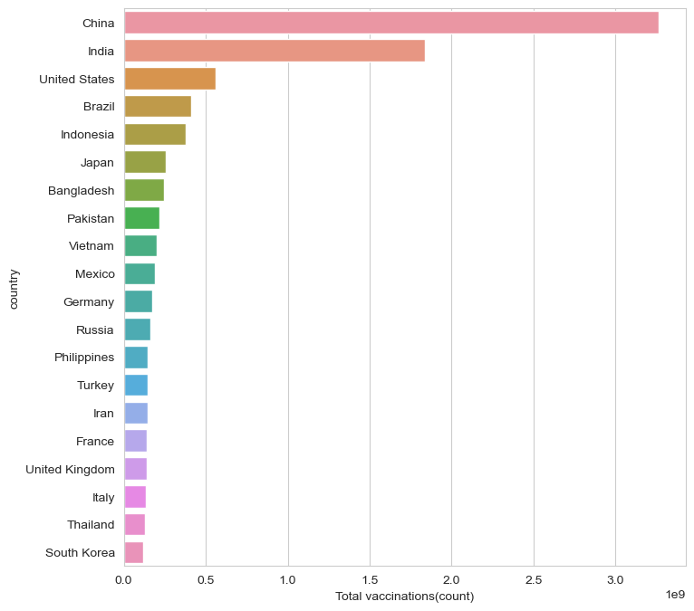

#Top countries with fully vaccinated peoples  
data["Full_vaccinations(count)"]= data.groupby("country").people_fully_vaccinated.tail(1)  
  
data.groupby("country")["Full_vaccinations(count)"].mean().sort_values(ascending= False).head(20)

country  
India 828229455.0  
United States 217498967.0  
Brazil 160272858.0  
Indonesia 158830466.0  
Bangladesh 107712737.0  
Pakistan 101881176.0  
Japan 100633737.0  
Mexico 79711762.0  
Vietnam 77754108.0  
Russia 72841232.0  
Philippines 65804988.0  
Germany 63142649.0  
Iran 56810058.0  
Turkey 52968985.0  
France 52438706.0  
Thailand 50159803.0  
United Kingdom 49404026.0  
Italy 47817555.0  
South Korea 44482876.0  
England 41501690.0  
Name: Full_vaccinations(count), dtype: float64

#barplot visualization of top countries with most full vaccinations  
  
sns.set_style("whitegrid")  
plt.figure(figsize= (8,8))  
ax= sns.barplot(x.values,x.index)  
ax.set_xlabel("Fully vaccinated(count)")  
plt.show()

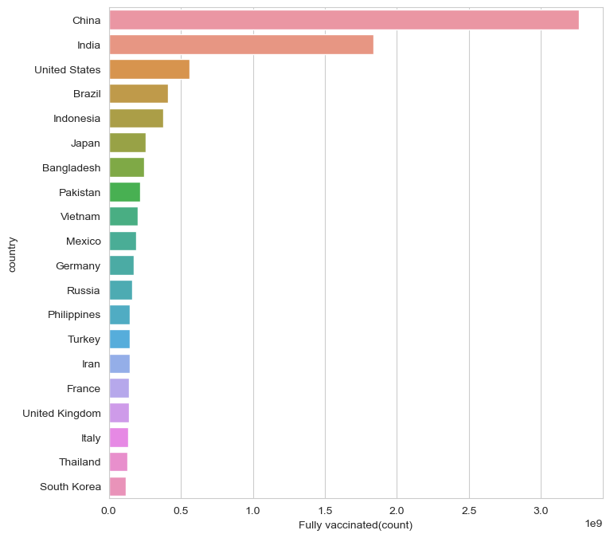

#most common vaccines  
data.vaccines.value_counts()

Johnson&Johnson, Moderna, Oxford/AstraZeneca, Pfizer/BioNTech 7608  
Moderna, Oxford/AstraZeneca, Pfizer/BioNTech 6263  
Oxford/AstraZeneca 6022  
Oxford/AstraZeneca, Pfizer/BioNTech 4629  
Johnson&Johnson, Moderna, Novavax, Oxford/AstraZeneca, Pfizer/BioNTech 3564  
 ...   
Johnson&Johnson, Oxford/AstraZeneca, Sinovac 312  
Moderna, Oxford/AstraZeneca, Pfizer/BioNTech, Sinovac, Sputnik V 311  
Johnson&Johnson, Moderna 251  
Johnson&Johnson, Pfizer/BioNTech, Sinopharm/Beijing 228  
EpiVacCorona, Oxford/AstraZeneca, QazVac, Sinopharm/Beijing, Sputnik V, ZF2001 190  
Name: vaccines, Length: 84, dtype: int64

#daily vaccinations  
x= data.groupby("date").daily_vaccinations.sum()  
plt.figure(figsize= (15,5))  
sns.lineplot(x.index,x.values)  
plt.show()

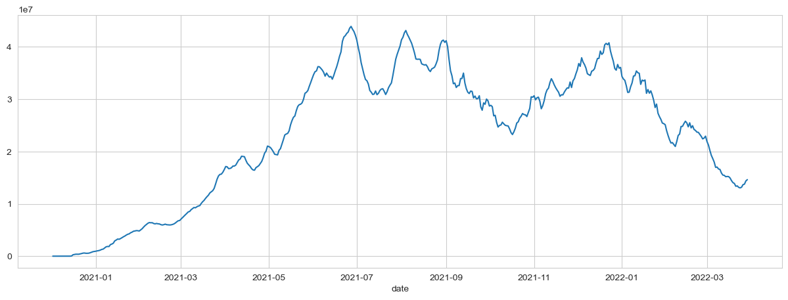

#preferred vaccine in India  
x= data[data["country"]=="India"]  
z= x.vaccines.value_counts()  
c= list(z.index)  
c

['Covaxin, Oxford/AstraZeneca, Sputnik V']

#COMPARING TOP 5 COUNTRIES WITH MOST VACCINATIONS

data.groupby("country")["Total_vaccinations(count)"].mean().sort_values(ascending= False).head()

country  
China 3.263129e+09  
India 1.834501e+09  
United States 5.601818e+08  
Brazil 4.135596e+08  
Indonesia 3.771089e+08  
Name: Total_vaccinations(count), dtype: float64

#creating dataframe for top 5 vaccinated countries  
x= data.loc[(data.country== "United States") | (data.country== "China")| (data.country== "India")| (data.country== "Unted Kingdom")|(data.country== "England")]

#total vaccination comparison  
plt.figure(figsize= (15,5))  
sns.lineplot(x= "date",y= "total_vaccinations" ,data= x,hue= "country")  
plt.show()

